**K8’s-04**  
  
  
  
1) Deploy an application using a Deployment with 3 replicas and a rolling update strategy.  
  
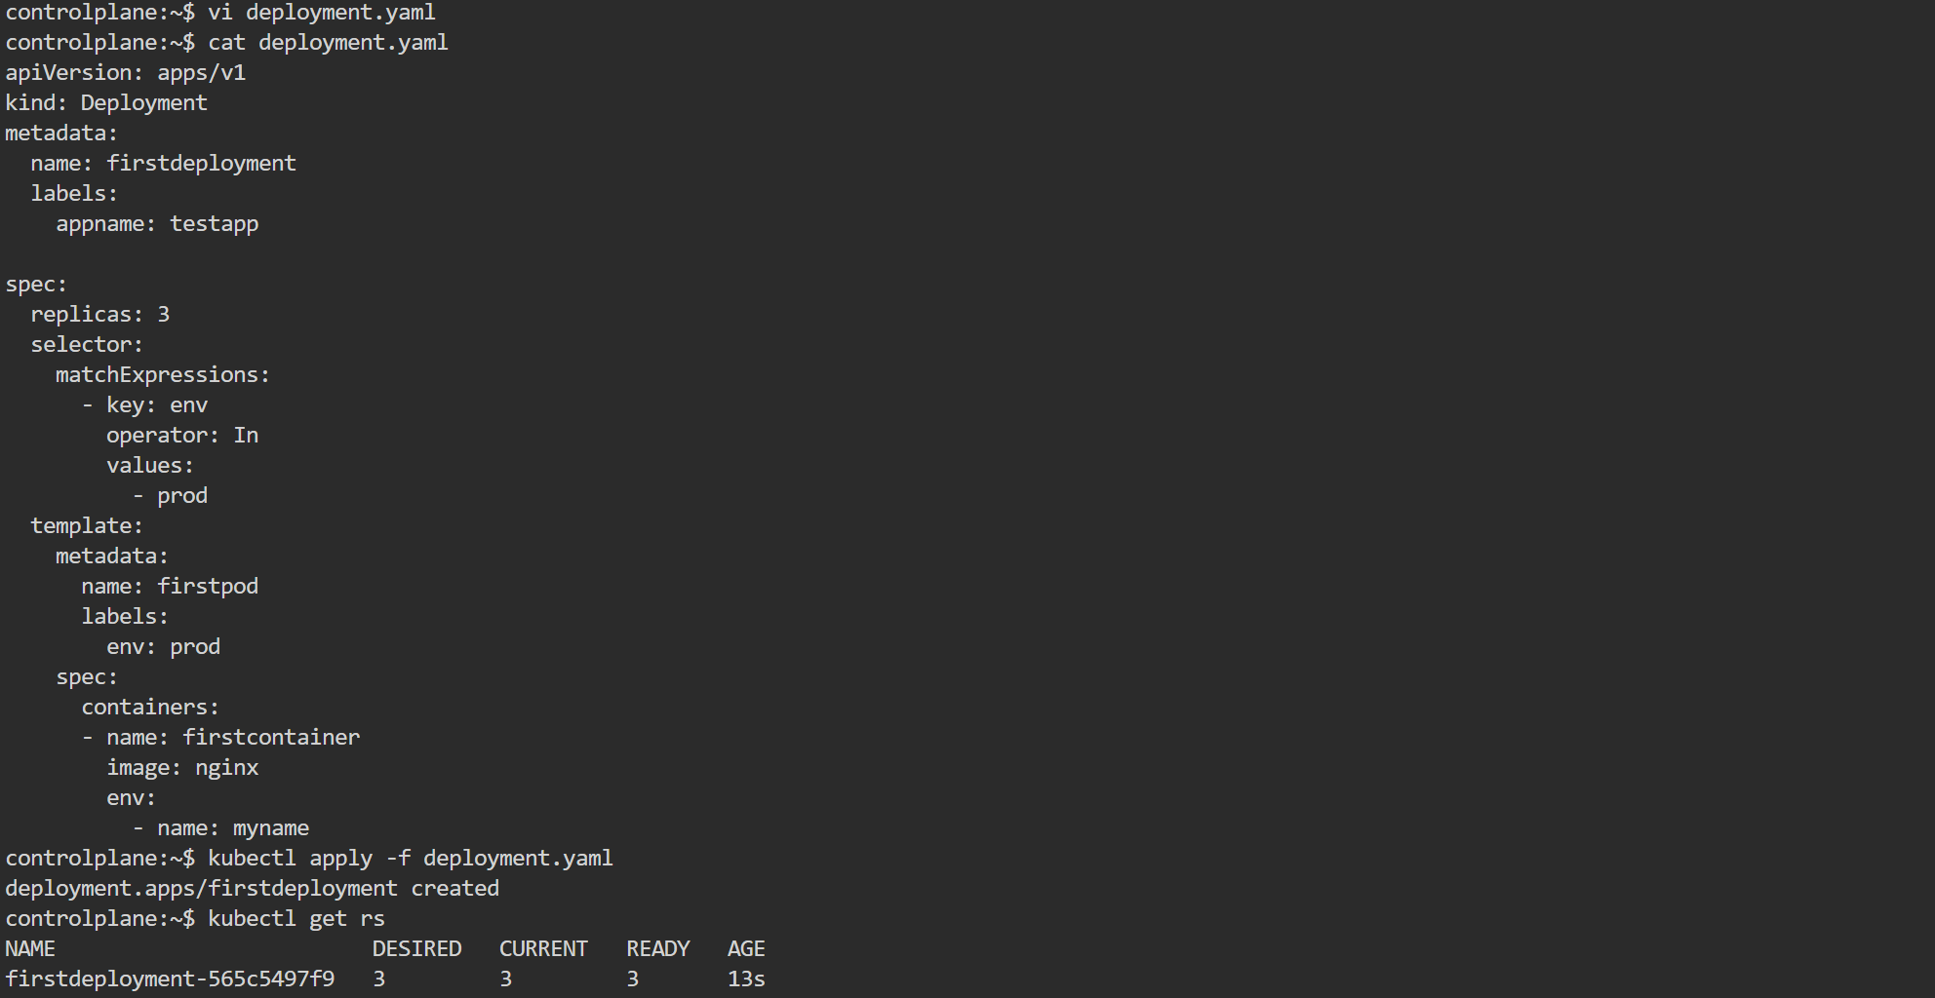  
  
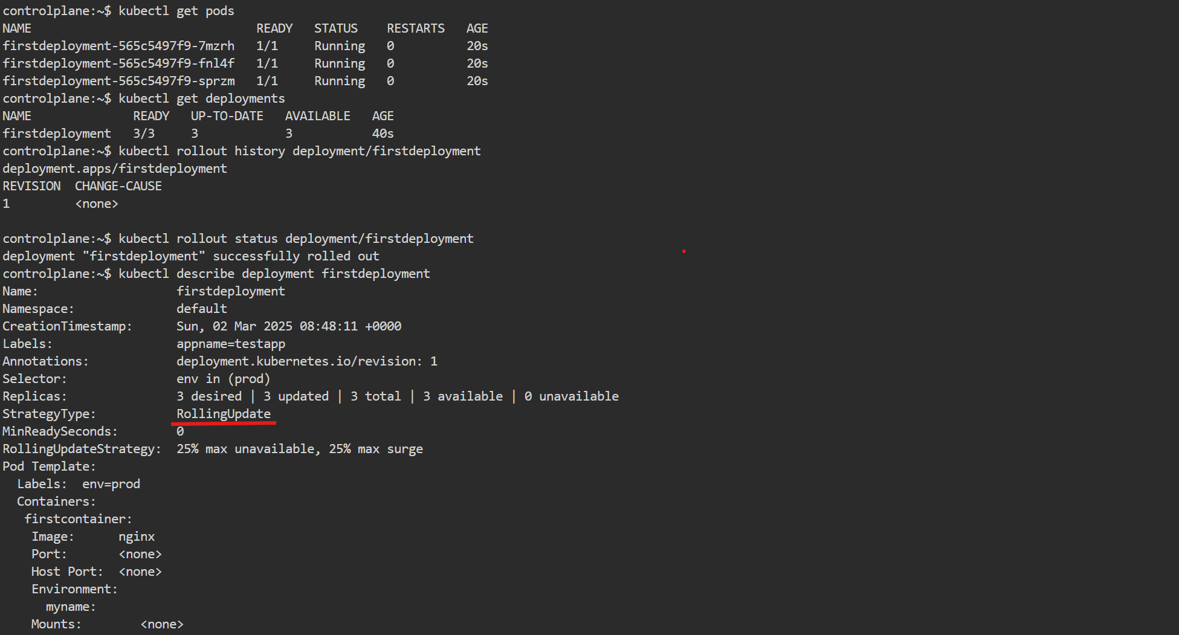

2) Configure a Deployment with a Recreate strategy and observe the downtime.  
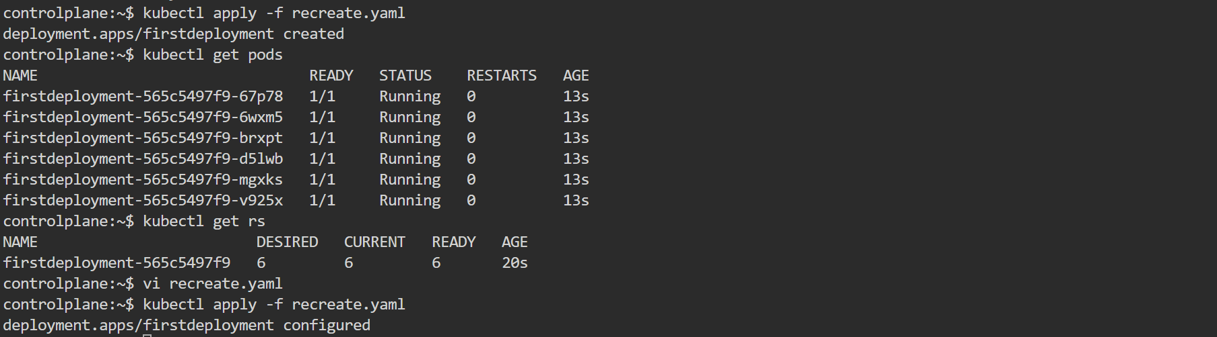  
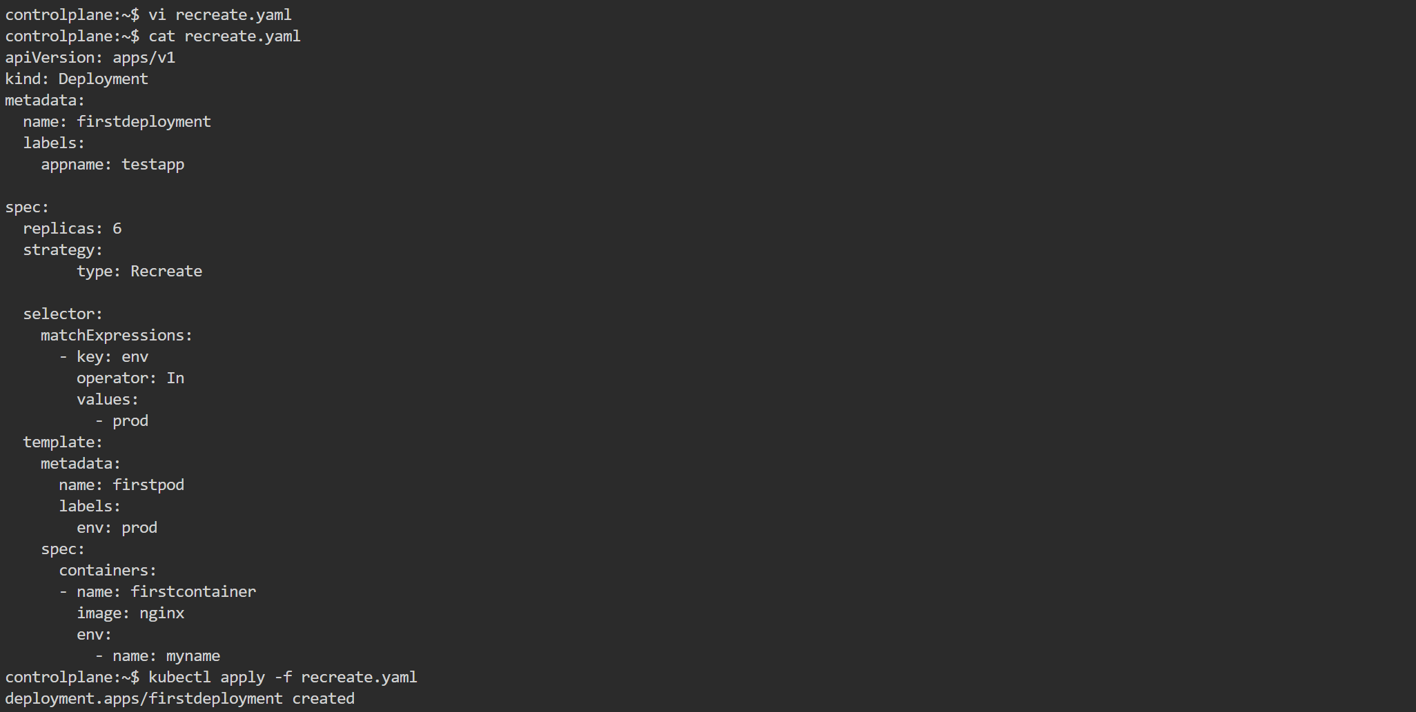  
  
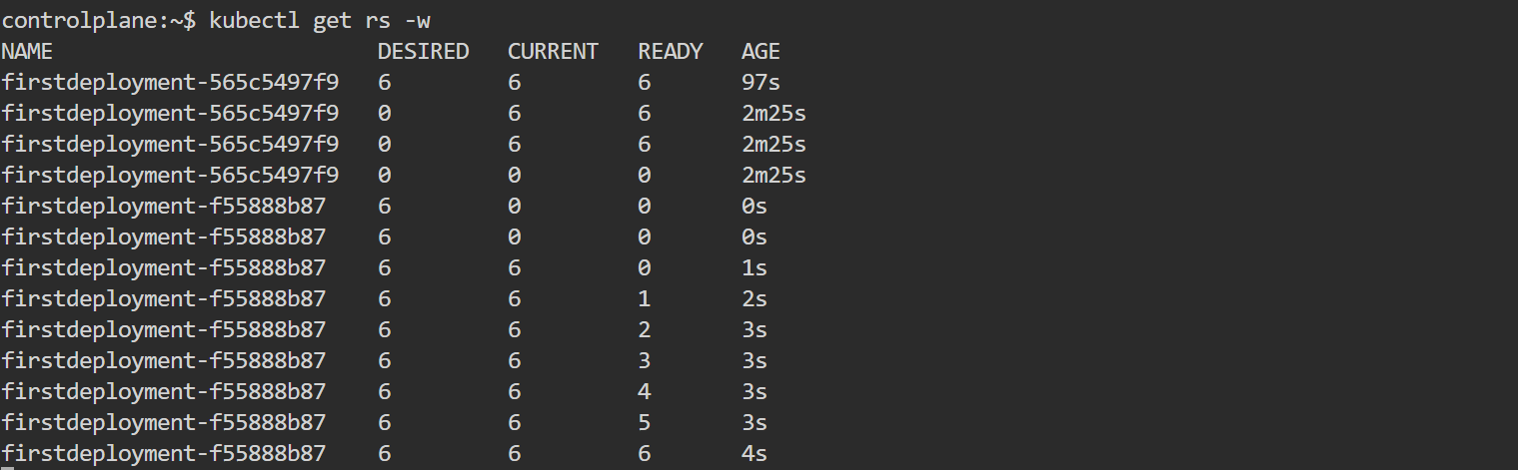  
  
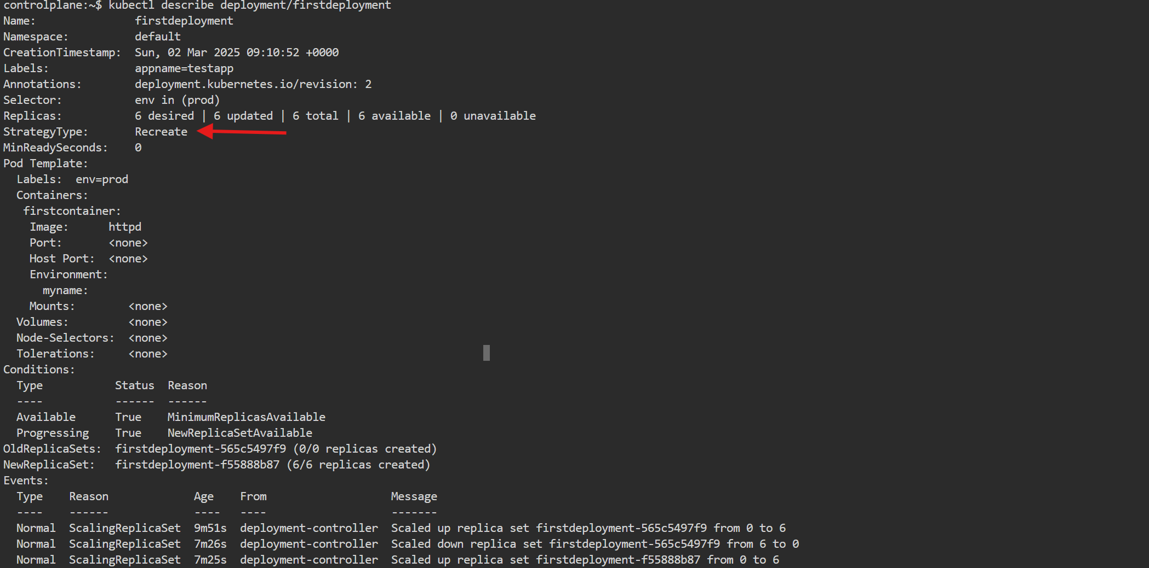  
3) Update an existing Deployment and perform a rollback to the previous version.  
  
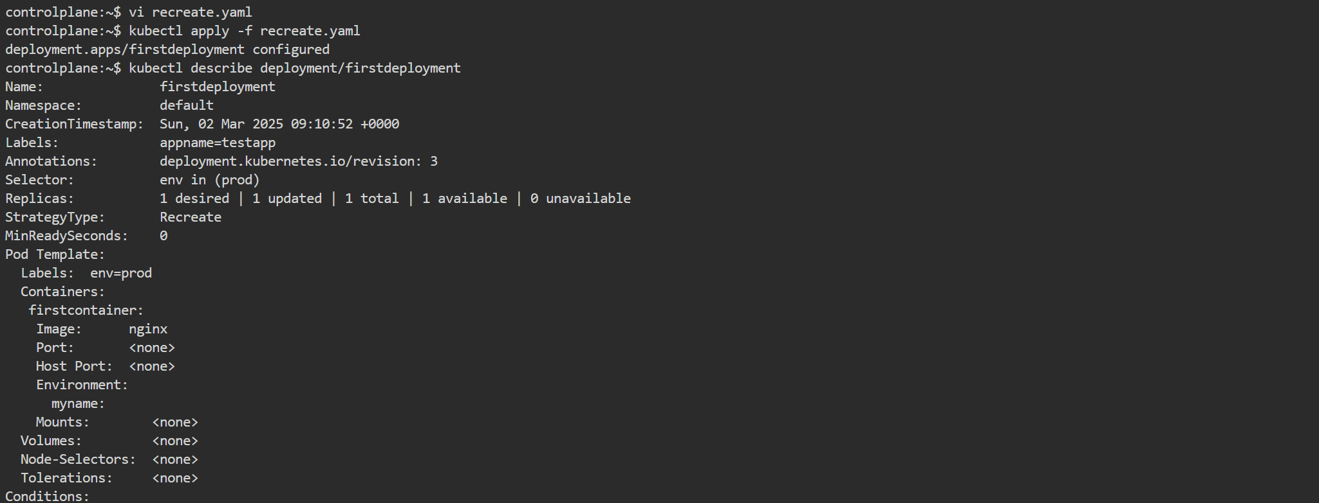  
  
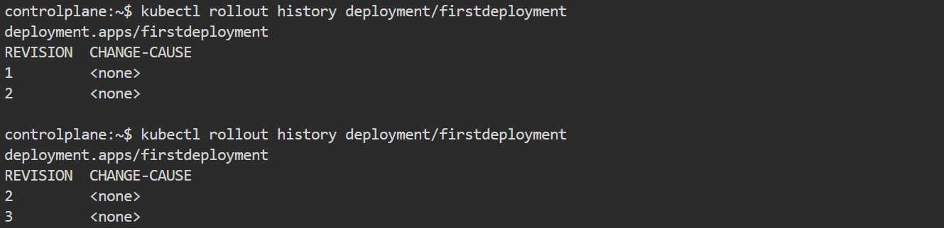  
  
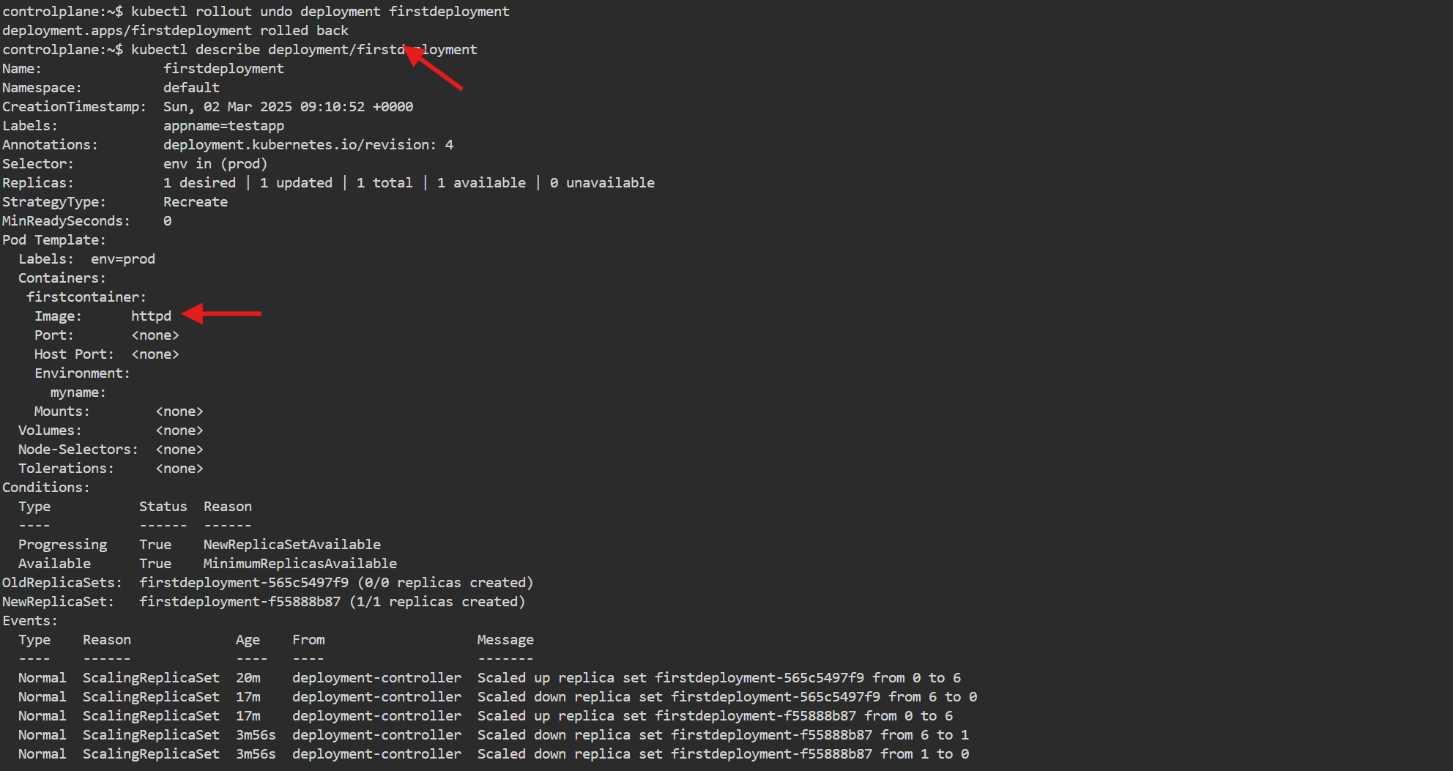  
  
  
  
4) Modify a Deployment to add resource requests and limits for CPU and memory.

5) Create a Deployment with Max-surge and Max-unavailable configurations.  
  
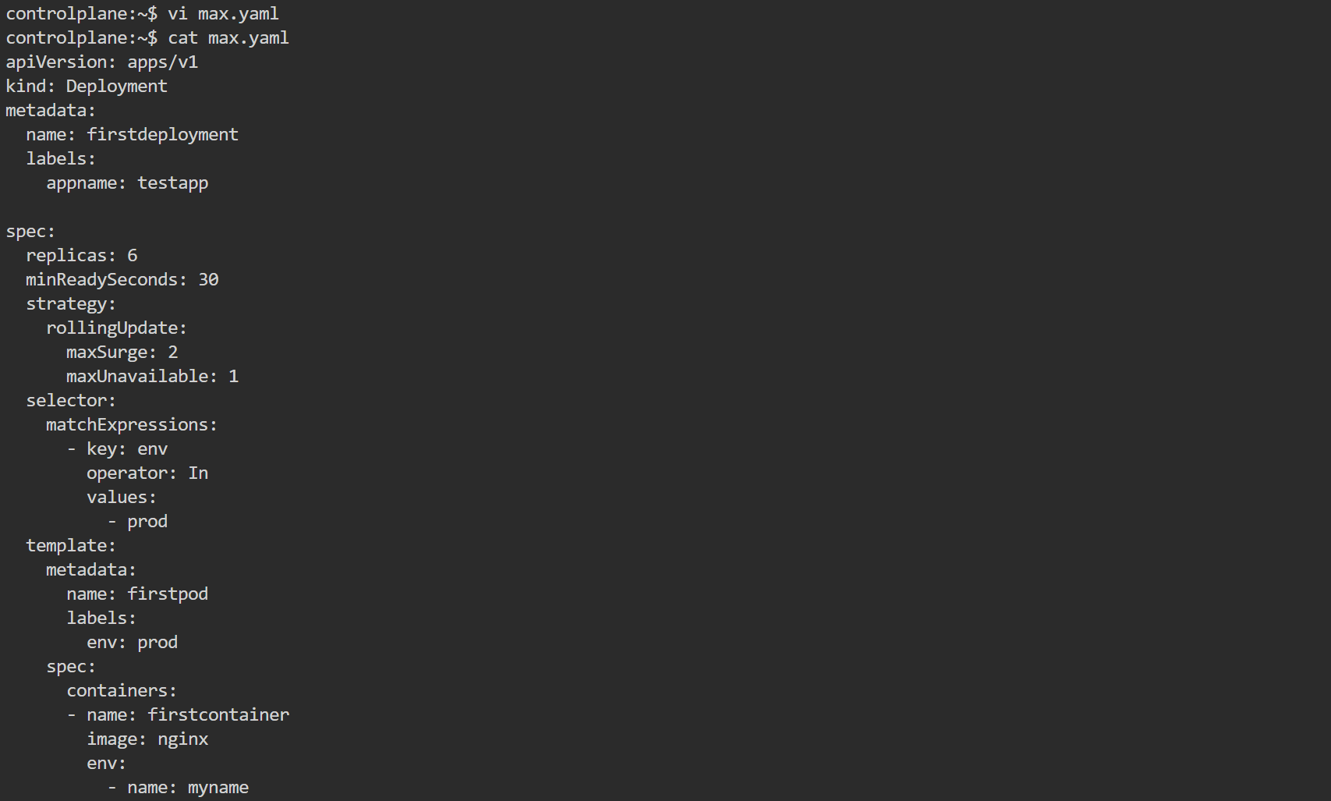  
  
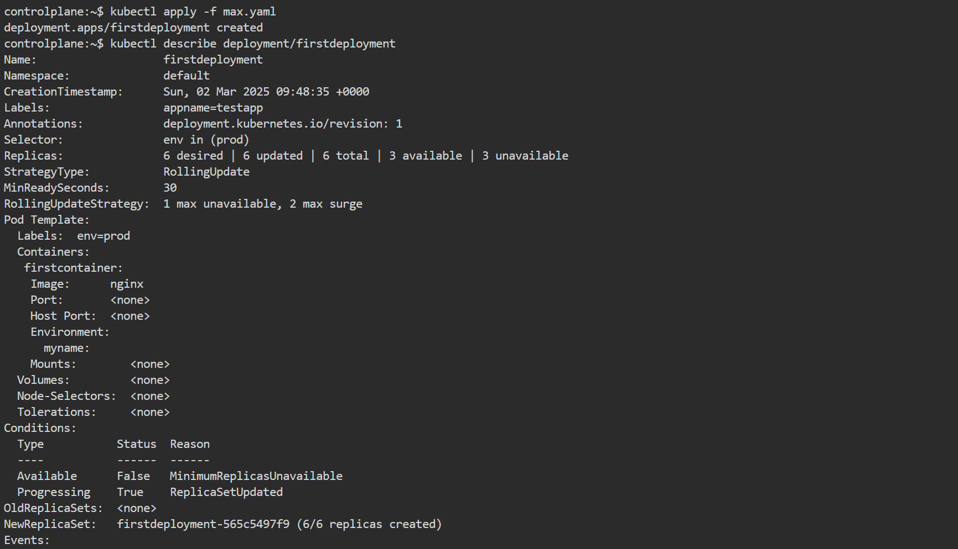  
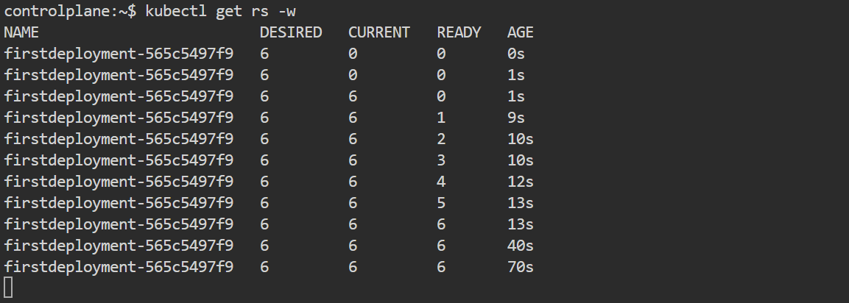  
  
6) Set up a Deployment with a custom revision history limit.  
  
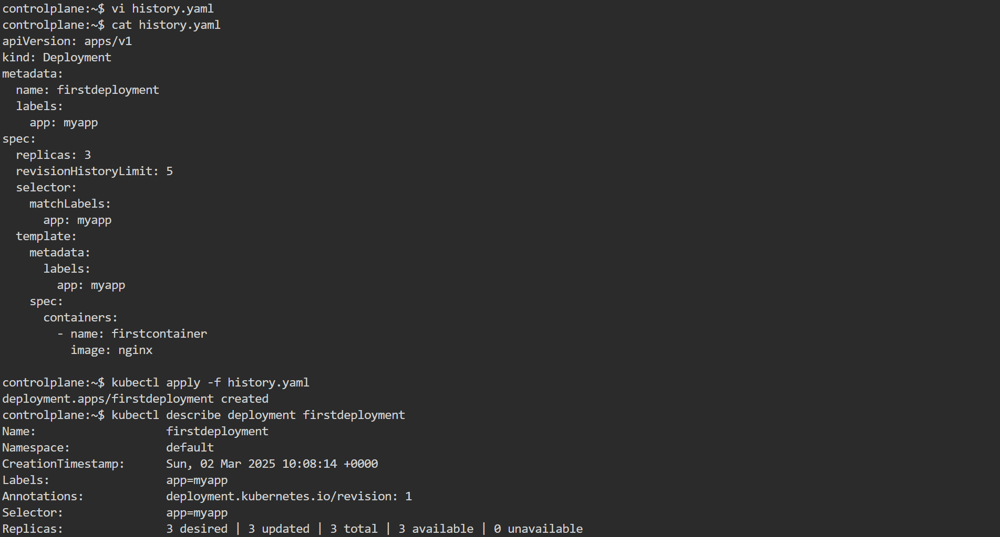  
  
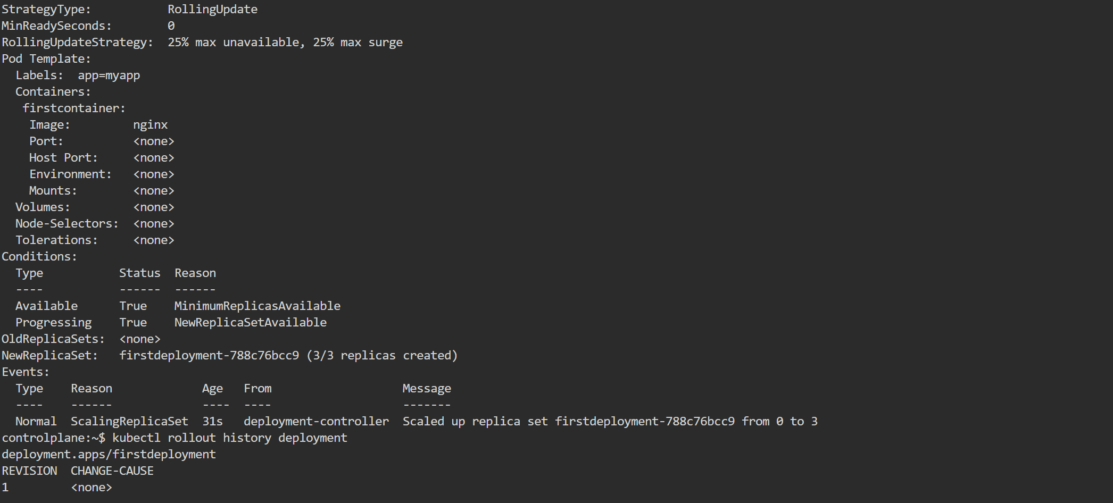  
  
7) Pause a Deployment during an update, and then resume it.  
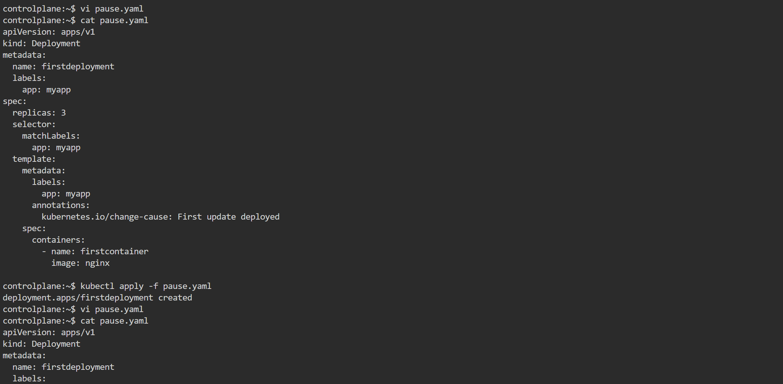  
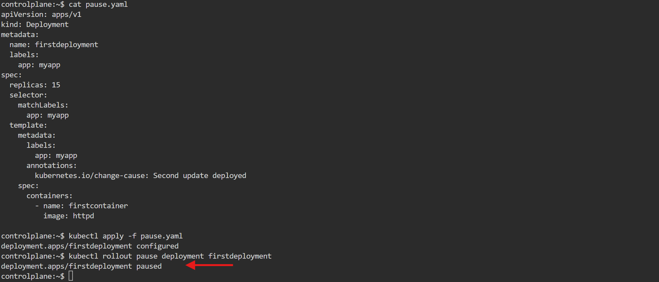  
  
  
  
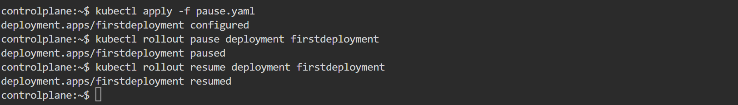  
  


8) Create a pod using resource requests for memory and CPU, and observe how the scheduler assigns it to a node.